Centre for Dalit Rights, Rajasthan
112, Surya Nagar, Gopalpura Bye Pass, Jaipur-302015
Team List-
S.No | Name | Designation | Immage
 | Mr. Satish Kumar Advocate | Director | 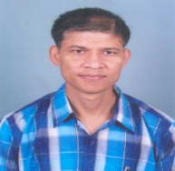
 | Mr. Chanda Lal Bairwa | Prog. Coordinator | 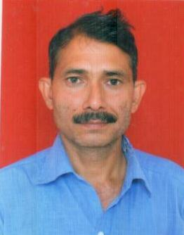
 | Ms. Grijesh Dinkar | State Coordinator DMM | 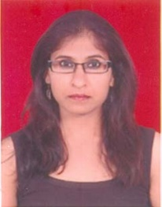
 | Mr. Mukesh Mehra | Finance Officer | 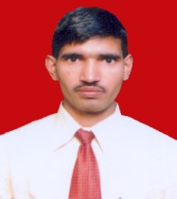
 | Mr. Bhagwan Sahay Bairwa | Administrator | 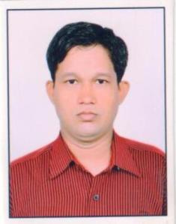
 | Mr. Meetha Lal Jatav | MIS Coordinator | 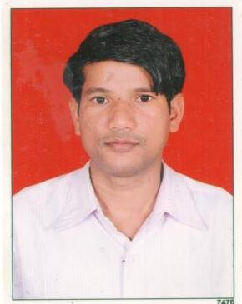
 | Ms. Pooja Singh | Coordinator DMM | 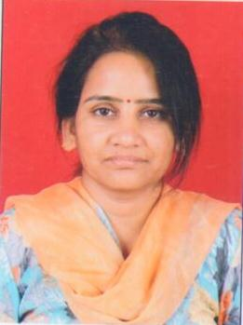
 | Mr. Ramesh Chand Bansal | District Coordinator, Ajmer | 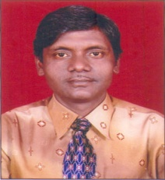
 | Mr. Banwari Lal Mimroth | District Coordinator, Alwar | 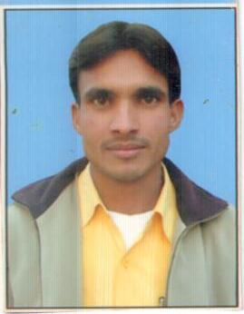
 | Mr. Mahesh Kumar Kain | District Coordinator, Bharatpur | 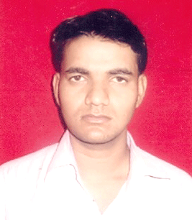
 | Mr. Mahaveer Singh Bhati | District Coordinator, Pali | 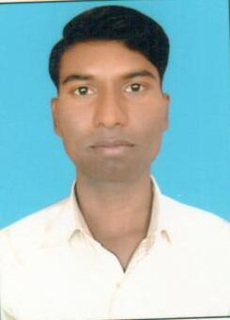
 | Mr. Lala Ram | Assistant Coordinator, Bharatpur | 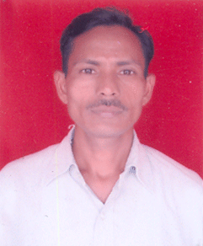
 | Mrs. Sunita Devi Bairwa | District Coordinator, DMM Dausa | 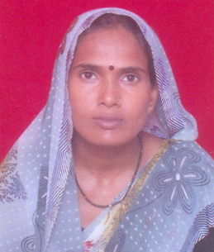
 | Smt.Dropati Jonwal | Assistant Coordinator, DMM Dausa | 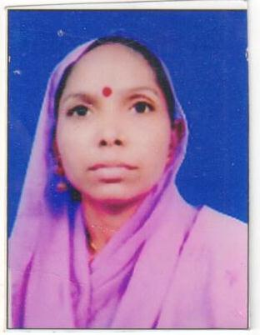
 | Mr Suresh Chand Bairwa | Coordinator , Dausa | 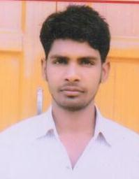
 | Mrs Indira Solanki | Assistant Coordinator, DMM Ajmer | 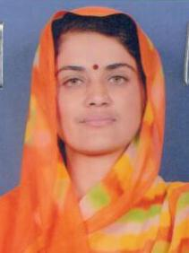
 | Ms. Chanda Bai | Assistant Coordinator, DMM Alwar | 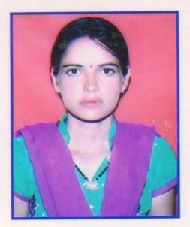
 | Mr Vinay Kumar | Office Attendant | 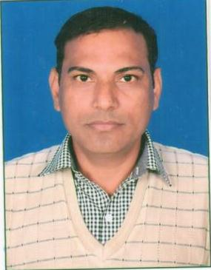
 | Mr. Matadeen Raigar | Driver | 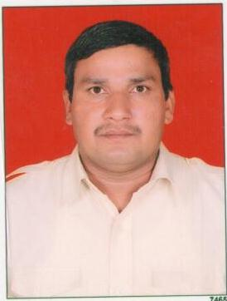
 | Mr Elam Chand Verma | Care Taker | 